AUTOMATED FINANCIAL PLANNING

Input:

1. **budget**
2. **time period**
3. **risk (low or high)**
4. **financial goal**

Solution:

Broad categories

1. **real estate (low risk)**
2. **fixed deposit + insurance**
3. **mutual funds + stock**
4. **gold**
5. **cash in bank**

On the basis of risk input by user:

**High Risk Investment Portfolio:**

1. **Real Estate**: 20%
2. **Stocks**: 40%
3. **Gold**: 10%
4. **Fixed Deposit**: 10%
5. **Cash in Bank**: 20%

**Low Risk Investment Portfolio:**

1. **Real Estate**: 10%
2. **Stocks**: 20%
3. **Gold**: 5%
4. **Fixed Deposit**: 40%
5. **Cash in Bank**: 25%

We will be doing all the predictions for real estate, stocks, gold, fixed deposit separately and finally giving out the profit that person may be getting at the end of the time period input by the user.

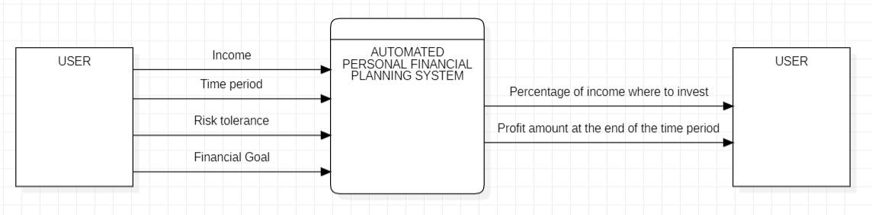

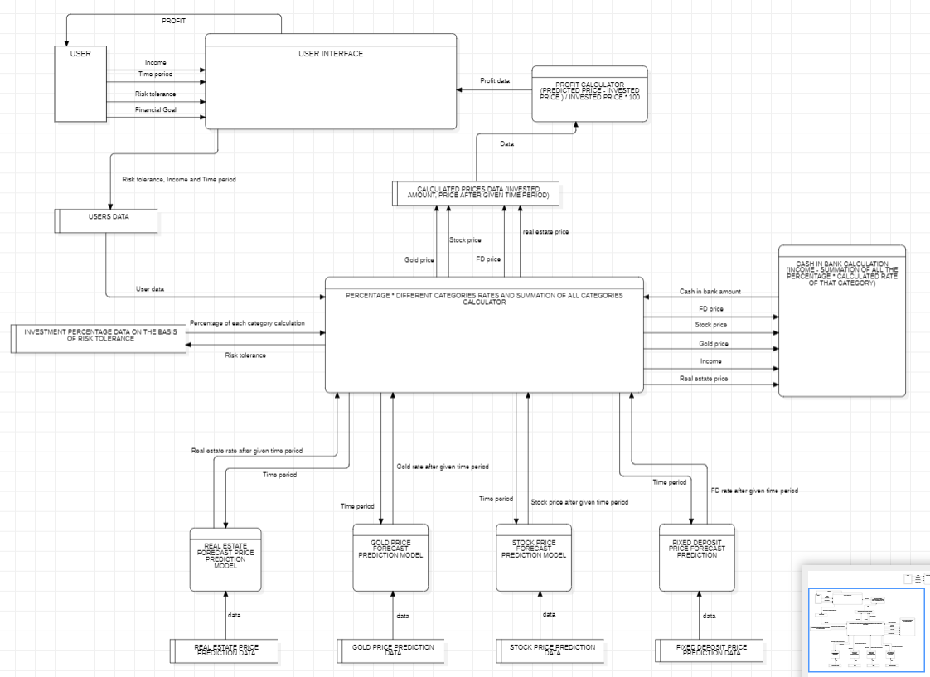

Output:

**Amount to invest in different categories and profit they will be getting at the end of the time period.**

**Problem statement:**

Develop an automated financial planning system aimed at predicting the profit for an individual based on their income, time period, and risk tolerance. The system should recommend optimal investment allocations across various asset classes, including real estate, fixed deposits, stocks, gold, and cash in the bank, to maximize the user's profit within the given time frame. The system should utilize historical data on gold prices, stock prices, fixed deposit rates, and real estate market trends to forecast the future prices of these assets at the end of the specified time period. It should calculate the expected returns and risks associated with each investment option, generate personalized investment recommendations based on user input, and calculate the expected profit percentage for each investment category and the total profit at the end of the given time period.

**Solution:**

1. Data Collection: Gather historical data on gold prices, stock prices, fixed deposit rates, and real estate trends.
2. Predictive Modelling: Use machine learning to forecast future prices of assets based on historical data and user parameters.
3. Investment Allocation: Recommend optimal allocations across real estate, fixed deposits, stocks, gold, and cash based on user's risk tolerance and income.
4. Profit Calculation: Calculate expected profit percentages for each category and total profit at the end of the specified time period.
5. Output Generation: Present recommendations and profit insights to the user via a user-friendly interface.
6. Continuous Improvement: Update models and strategies regularly to enhance accuracy and effectiveness.

This solution aims to provide personalized investment advice and accurate profit predictions to help users achieve their financial goals.